Ornamentation Melisma As A Frm Of Variation
In The Art Of Al-Qur’an Recitation

Suryati

Music Departement, Faculty of Performing Arts
Indonesia Institute of the Arts Yogyakarta

ABSTRACT
Ornamentation is a form of artwork variation intentionally added or created with an intention of making it more beautiful. Ornamentation found in music means addition of several notes or notation in melody, usually one syllable applied for several tones well-known as the term melisma. Ornamentation or embellishment functions to beautify a melody, both vocal and instrumental. The ormentation form in Western music has been formulated sistematically signed by symbols, and therefore a singer or a music player can read as written in the part of the song. Ornamentation can also be in the form of improvisation or cengkok which is commonly sung by a singer to ornament voice in order to make it sound more beautiful. Ornamentation is also found in the art of Al-Qur’an recitation particularly the type of mujawwad. This art of Al-Qur’an recitation is one of Al-Qur’an recitations which is acceptable among wider community. This can be seen in the entire people of Indonesia’s life from the countryside to urban areas that Al-Qur’an chant using an art in the Islamic community both in religious ritual occasion and in social gathering is often heard. Moreover, a competition or Musabaqoh Tilawatil Qur’an (MTQ) is always held, which is regularly held each year from regional to national level, even international level. One type of interesting competitions found in MTQ is mujawwad, because there are many rhythms (Nagham )which are applied. This dicussion focuses on the formulation of ornamentation form in the art of Al-Qur’an recitation of mujawwad type applying some variations and then the relations between the chant ornamentation of melisma and the technique of vocalization. The art of Al-Qur’an recitation of mujawwad type is embellished by many melody ornamentation in the form of melismatis.

Keywords: Ornamentation, The Art of Al-Qur’an Recitation, Mujawwad.

- INTRODUCTION
Art is incarnation of beauty embedded in the human soul, born by means of communication tool into a form which can be caught by hearing sense (auditory arts), sight sense (paint art), or born by means of motion (dance art, play). Art is a result of human expression shown in the form of motion arts, fine arts dan auditory arts. Auditory arts is divided into 2 parts, namely the arts of literature and music. Literature art includes prose and poetry, whereas music art includes vocal music and instrumental music. Instrumental music is music produced by playing music instruments as the source of sound, whereas vocal music or song is music produced from the source of sound such as human vocal chords. Abdullah Totong Mahmud defines music as the art of arranging notes to become sound patterns containing meaning. Furthermore, M. Soeharto states that sound which is classified in term of music definition is not only produced from music instrument but also human’s voice (vocal).
A music composition, particularly in the Baroque and Classical periods, many music ornamentation are found. Ornamentation meant here is the notation added in a melody, not including the notation of melody and the bar. A number of ornamentation commonly are signed by standard symbols in music notation, but other notation can be added with small notation, or are only written normally. Ornamentation is a musical term meaning addition of several tones or notation in melody, usually one syllable for several tones known as the term melisma (Taylor, 1989: 7). Ornamentation or embellishment functions to beautify in melody, both vocal and instrumental.
Ornamentation applied in Western is commonly structured and written sistematically in the musical score. Therefore, a singer in singing the song in accordance with a musical score which its rhythm of notation score and sukat (time signature) is determined. Ornamentation or embellishment commonly occurs when a song is sung by a single performer(Solo). However, not all ornamentation can be formulated structured, as well as a singer who spontaneously creates improvisation or cengkok. This kind of ornamentation or embellishment occurs because of the creativity or ability of a singer. Ornamentation can also occur in the art of Al-Qur’an recitation especially in the style of mujawwad commonly applied for Musabaqoh Tilawatil Qur’an (MTQ).
In Islam, the peak of auditory art is tilawah Al-Qur’an as the sunnah prayer having many virtue (Munawwir, 1997: 471). Auditory art or praise to Alloh can always be found as a whole-hearted expression both inside or outside mosque. In Indonesia, the recitation of Al-Qur’an verses is commonly known as the art of Al-Qur’an recitation (Qira’ah) which is a term meaning ‘to sing liturgy (ghina), adzan (the call to prayer), and a variety of religious songs found in the areas of Muslims in all parts of Indonesia (Nurudin, 2015: 21).
The art of Al-Qur’an recitation named Qiro’ah Al-Qur’an which has tajwid and is beautified with rhythm and song or in other words nagham, can be classified into the type of Handasah al-shaut or vocal art (Al Faruqi, 1996: 475). Qira’ah comes from the word qira’at meaning recitation. Mujawwad is one of types of the art of Al-Qur’an recitation which can be heard in almost each opportunity, with various listeners in each angle of Islamic world which is the most pervasive one in Islam culture. The art of Al-Qur’an recitation using the style of Qira’ah is commonly known as mujawwad style meaning good. The style chants completely by using embellishment (ornamentation of melody) in order to make it beautiful. Liukan-liukan in the art of Al-Qur’an recitation of mujawwad style of each person is different, in accordance with the creativity and ability of Qori/Qorih. A man who recites Al-Qur’an is named Qori, whereas a woman recites Al-Qur’an is named Qori’ah.
This art of Al-Qur’an recitation is one of those accepted in the wider community. This can be seen in the entire community from village to all parts of Indonesia which the art of Al-Qur’an recitation is often heard in Islamic community both in the religious ritual and social gathering. Besides, the art of Al-Qur’an recitation is also often showed and is contested directly in religious events known as Musabaqoh Tilawatil Qur’an (MTQ) including the types of recitation such as tartil, murottal, and Qiro’ah (mujawwad) which is annually held both in the local level to the National level even international level from various category levels of students, university students, and public.
Someone chanting Al-Qur’an is called Qori/Qori’ah, as well as someone singing songs is called a singer. Singing by producing a voice which is good, melodious, and beautiful requires a good and appropriate vocalizaton technique. Therefore, a Qori/Qori’ah and a singer in producing a beautiful, melodious voice which is good and appropriate are required to be able to master vocalization technique appropriately. Of course, it needs an intensive process of practice. Vocalization technique is needed by someone who wants to obtain a deep understanding of auditory art or vocal technique. The basic technique of managing vocal cannot be separated from vocalization. The technique is important for all languages, due to the sound formation and vocal pronunciation in articulation emphasis. This vocalization is done in the learning process of reciting by memorizing the pronunciation of letters appropriately and clearly. This vocalization is also applied in term of reciting Al-Qur’an. We must learn how to pronounce hijaiyah letters using tajwid appropriately and therefore it can be heard clearly since Al-Qur’an letters have specific and unique characters(Anwar, 2012: 33).
Regarding the above mentioned statement, chanting Al-Qur’an verses applying the type of mujawwad shows a connection between ornamentation application and vocalization technique. Therefore, this discussion focuses on the formulation of the art of Al-Qur’an recitation of mujawwad by applying some variation and the relation between the ornamentation chant and vocalization technique. In observing and examining, the discussion of the art of Al-Qur’an recitation applied qualitative decriptive analysis method by using musicology approach to transcribe, to analyze ornamentation and the relation of vocalization technique occurring in the art of Al-Qur’an recitation.

- RESEARCH METHOD
This research is a part of dissertation method about “A Study Case of Vocalization Technique and Ornamentation of the Art of Al-Qur’an Recitation: Musabaqoh Tilawatil Qur’an (MTQ)in the National Level”. This research method applied descriptive and interpretative analysis by using qualitative data. In a qualitative research, a researcher is required to be able to explain all trusted parts of known resources and does not create contradictions by the presented interpretation. (R.M. Soedarsono, 1999).
The first step conducted intensively was literature study which aimed to obtain literature related to the research objects which were conducted. In its implementation, the materials needed are divided into two parts, namely: first, finding references related to concept-making and second, the materials can also be used to examine the problems and to be this research references. Besides, literature study aimed to avoid the similarity of problems object between the previous researcher and the researcher herself.
According to Alan P. Merriam, in his book entitled The Anthropology of Music, the terms of field technique and method are known. This technique means the collection of data conducted in detail in the field, whereas field method has a wider range of scope including theoretical basis becoming references for field research technique. The technique indicates problem-solving, the collection of data each day, whereas the method includes technique and various problem-solving as a framework in the field. Observation is a direct observation to the field to observe object carefully and sistematically. This observation was conducted directly on the behavior of Qori/Qoriah in the chanting of Al-Qur’an verses in Musabaqoh Tilawatil Qur’an (MTQ) in the National level. This observation focuses on the observation of practicing process for MTQ, ways of chanting, and a variety of song variation form in the ornamentation of verses chanting melody.
An interview is a conversation done by two sides with certain intention, which is by raising questions and providing answers over the questions. This interview was conducted in order to obtain data which could not be obtained in the observation. The interview was intended toward the MTQ organizer committee in the level of regional and National in order to ascertain the process of MTQ implementation and its result of championship, and to obtain audio-visual CD recording of the championship. Then, the interview was also intended toward those reciting Al-Qur’an or the best Qori/Qoriah of adult category, to find out techniques, and forms of ornamentation variation done in the art of Al-Qur’an recitation.
Data analysis was obtained from the result of observation, interview, document recording, literature study, and informant results which were analyzed qualitatively. The data which were obtained were arranged in certain categories in referring to the main discussion set in the research. Research data including musical data, observation and information were analyzed by applying three analysis approaches, in musicology, aesthetic, and linguistic assistance of Arabic and Al-Qur’an. Those three factors were correlated into a auditory art which is related to each other between the tone, language, and beauty. The analysis conducted towards musical samples by connecting the research subjects with the concepts about the form of music. The target achievement from the method applied was conducted through several steps.
Transcription/formulation was conducted in musicology obtained from the recording result of Al-Qur’an chanting in the championship of Musabaqoh Tilawatil Qur’an (MTQ) in the National level. In this case, it can be said that the effort of denoting musical melody is a process of interpretation obtained from the result of listening through audio which is an effort of producing the descriptive results of musicology, both horizontally in term of duration and rhythm, and vertical dimension in term of pitch or height frequency. Regarding the above mentioned statement, Werren F.Prince in his book entitled A Paradigm for Research on Music Listening mentioning that transcribing music requires musical experiences and ability, in order to show the memory talent and the ability related to the responds in the listening process.

- DISCUSSION
- The song of Al-Qur’an recitement
Basically, Al-Qur’an recitation cannot be separated from song. In chanting Al-Qur’an or taghanni in reciting Al-Qur’an, it will be more beautiful when the voice of reciting Al-Qur’an verses is applied with a variety of song variation. Al-Qur’an song is the strain of intonation or reading which is sounded in the beauty of tones, variation as well as improvisation which is in tune with the messages revealed by the verses which are read. In creating the art of Al-Qur’an recitation which has a lot of variations, it must be accompanied with makhrajul letter or reading letters on each syllable appropriately, as well as the chanting of beautiful and smooth voice. As Rosul said “embellish Al-Qur’an using your voice”, and therefore it will not make the listeners bored and it will be a heartwarming recitation both for readers and listeners.
The art of Al-Qur’an recitation just showed its existence in the early 20th M Century which was centered in Makkah and Madinah also in Indonesia as a country which is predominantly populated by Muslims who are very active in transferring knowledge of religions including nazam (poetry) since the early 19th Century. Nazm (poetry) is one of art expression forms which has been growing up since a long time ago. Ibnu Manzur stated that there are two theories about its origin of Al-Qur’an nazm. First, Al-Qur’an nazm was from the Arabs’ ancestors’ song. Second, Al-Qur’an nazm was inspired by the songs of kafir slaves who became prisoners of war. These two theories emphasize that the songs of Al-Qur’an are from Arabic traditional vocabularies. According to those theories, it is emphasized that those songs of Al-Qur’an, ideally has Arabic rhythm nuance.
In the art of Al-Qur’an recitation or taghanni in reciting Al-Qur’an, there are two versions namely Mekkah version, known with the song of Banjakah, Hijaz, Mayya, Rakby, Jaharkah, Sikah, and Dukkah. Unlike Mekkah version, Eqypt version is known as the song of Bayyati, Shaba, Hijaz, Nahawand, Sikah, Rast, Jiharkah. Yet, the art of reciting Al-Qur’an known in Indonesia is the version of Egypt. Considering that the language of Al-Qur’an is Arabic, and therefore in chanting Al-Qur’an verses, we must apply the song of(maqam) Arabic or commonly known as Arabic ethnomusicology with maqamat Al-Arabiyyah. The seven maqam in chanting Al-Qur’an or taghanni reciting Al-Qur’an of Eqypt version, eacch song has voice characteristics and arrangement, as well as each musical notes, which can be described as follows.
- Maqam Bayyati; has the characteristics of soft, with melodic development, and seems more feminine.
- Maqam Shaba; has the characteristics of soft with the nuance of sorrow, and therefore it inspires the soul emotional feeling.
- Maqam Hijaz; This Maqam is very typical of Eastern culture, showing a beautiful impression.
- Maqam Nahawand; This Maqam shows a sad characteristic, which is suitable for chanting sya’ir or verses which had a nuance of sadness.
- Maqam Sikah; It is brought by using slow and solemn tempo, having the characteristic of Eastern culture with brilliant strains which is easy to recognize and very popular.
- Maqam Rast; This Maqam has the characteristic of a dinamic and vibrant song. This Maqam is often used to echo adzan and liked by the Arabs.
- Maqam Jiharkah; This has the characteristics of rhythm Raml. The ryhthm creates a deep feeling. It is often chanted during Takbir of the Eid Festival, Eid Al-Fitr and Eid Al-Adha.

Those seven main songs in the art of Al-Qur’an recitation are commonly brought in several steps of tone levels, starting from the lowest to the highest tones. In the arrangement of the art of Al-Qur’an recitation, there are four stages of tones levels in tilawah of Al-Qur’an, namely; (1) Qarar (basic); this is a soft sound or the lowest sound, , (2) Nawa (intermediate); this is the medium or intermediate located between the low and high voices, (3) Jawab (high); the sound recognized here is getting up stronger, and (4) Jawabul Jawab (the highest); This is the kind of sound which is very powerful.
In the art of Al-Qur’an recitation, there are some style levels as explained by Munawwir in the thesis of Yaser Arafat entitled “Tarekat Tilawatiyah”, explaining in details about the styles of Al-Qur’an recitation as follows yaitu;
- Tartil is a manner of reciting Al-Qur'an using a pleasant voice and slowly by implementing the rules of reciting approriately.
- Murottal is a style of reciting Al-Qur’an focusing on two points, such as the correctness and song of Al-Qur’an.
- Mujawwad is a style of Al-Qur’an recitation which is full of ornamentation and perfect both in its tone levels and song variation as well as its song type.

- Ornamentation of the Art of Al-Qur’an Recitation
Ornamentation or art embellishment has several variations and therefore it will not be monotonous and will be more varied. There are various forms of ornamentation which are adjusted with the characters of songs and based on the needs. All songs, basically, can use varied variations so that a song can sound more lively and beautiful. In applying ornamentation in each song, it is not just adding the ascending-descending tones or sound, but it must be in accordance with the previous notes and therefore it will sould harmonious. Ornamentation is not only used in songs in general, but also it is applied in the art of Al-Qur’an recitation particularly in the type of mujawwad.
Ornamentation applied in the art of Al-Qur’an recitation particularly in the type of mujawwad can be seen from the variation of each maqam, because each maqam has its own characteristic. In general, Qori in applying variation or ornamentation refers to several Sheikh from Egypt or previous Qori- Qori which is learned orally, and has not yet been formulated in writing. Terefore, a Qori/Qoriah learning and explroring the art of Al- Qur’an recitation must have a good sense of musical hearing, which is in term music is known as solfegio (a good sense of musicality).
The ornamentation in the art of Al-Qur’an recitation particularly the type of mujawwad commonly is found in mad or Ikhfa. Mad is the lengthening of sound which is symbolized as alif (ا), waw (و) and ya (ي), which is read with two harakat, for example, the recitation of “Basmallah” (Bismillaahirrahmaanirrahiim). Ikhfa is to pronounce a letter with very light sound from the nose (vaguely), when the letters meet nun mati (ن) or tanwin. As mentioned earlier, commonly, Qori/Qori’ah in applying variation or ornamentation refers to some Sheikh from Egypt or previous Qori-Qori learned orally, and is not formulated in writing. Therefore, the attempt of formulating the forms of ornamentation occurring in the art of Al-Qur’an recitation is conducted, although it might not match exactly. It was conducted by taking some examples of Al-Qur’an verses chanted by the best Qori’ah of MTQ in the National level.
- The form of ornamentation of the art of Al-Qur’an recitation, mujawwad style
The form of ornamentation occurring in the art of Al-Qur’an reecitation has not yet been formulated in standard, even it can not be formulated surely. This is because the art of Al-Qur’an recitation is inherited from one generation to the next generation through the spoken tradition not in written. Therefore, the results obtained from one generation to another show slight difference eventhough there has been authenticity or maqom in the art of Al-Qur’an recitation being set. Eventhough the length of giving ornamentation has been set with harakat or beat, but the pitch can be heard clearly, according to the writer’s observation, pitch in the ornamentation chanted by Qori/Qori’ah can be formulated by applying symbols of block notation, its ascending and descending. Based on the result of ornamentation observation occurring in the art of Al-Qur’an recitation in MTQ of mujawwad style, the writer attempts to formulate several forms of ornamentation or variations included in the art of Al-Qur’an recitation particularly mad or sound extension.
- Ornamentation of mad ashli or mad thabi’i which the extension of its sound is symbolized with letter ya (ي), which is recited two harakat. It can be seen in the following example of “basmallah” recitation, Bismillaahirrahmaanirrahiim with maqam Bayyati asli Qoror tone(low) at the end of the word hiim, there is a little ornamentation of adding 2 tones below. The form of notation is as follows.
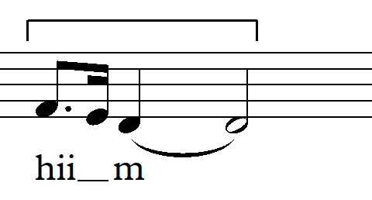
- Ornamentation of mad asli or mad thabi’i which the extension of its sound is symbolized with the letter waw (و) is recited with two harakat. It can be seen in the following example of yamsyuuna recitation with maqam Bayyati asli, Qoror tone (basic/low) on the syuu syllable, there is ornamentation of adding 3 tones; one tone below, the tone itself, and the tone above. Here is the form of the notation.
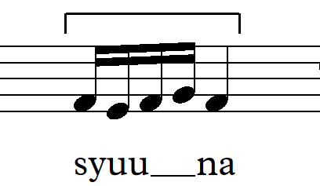
- Ornamentation of mad thabi’i which the extension of its sound is symbolized with letter ya and waw in maqam Bayyati shuri, using Jawab tone (high) is recited with two harakat. It can be seen in the following example of yabiituuna recitation in the word bii tuu, there is ornamentation of adding several tones above and below melismatically. Here is the form of the notation.
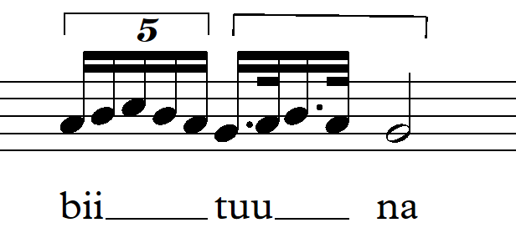
- Ornamentation of mad asli or mad thabi’i which the extension of its sound is symbolized with the letter alif (ا) is recited with two harakat. It can be seen in the following example of salaamaa recitation with maqam Bayyati asli, using the Nawa tone (average) in laa syllable, there is ornamentation of adding 3 tones; one tone below, the tone itself, and the tone above. Here is the notation form.
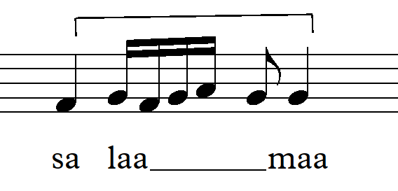
- Ornamentation of Mad Wajib Muttasil which the extension of its sound occurs when mad thabi’i letter is followed by hamzah (ء) in a word, it is recited with 2 ½ alif or 5 harakat. It can be seen in the next example of innahaa saaa’at recitation with maqam Bayyati Husseini, using Jawabul Jawab tone(high) in the saaa syllable, there is ornamentation of adding several tones moving downward and upward melismatically. The form of notation can be seen as the following.
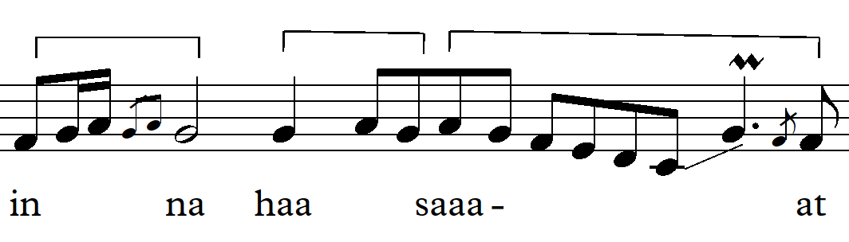
- Mad Lazim Harfi Mutsaqqal which the extension of its sound occurs when Mad Thabi'i meets the letter having tasydid (ّ) in a word, is read with 3 alif or 6 harakat. This can be seen in the following example of sujjadawwa reecitation with maqam Bayyati shuri, using Jawab tone(high) in daw syllable, there is ornamentation of adding 3 tones moving downward. The notation form is as follows.
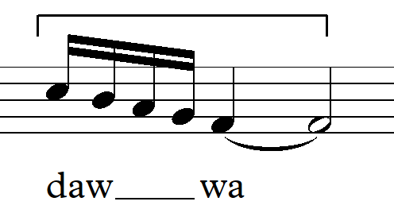
- Mad Lazim Harfi Mutsaqqal in the mustaqarrawwa recitation with maqam Bayyati Husseini, using Jawabul jawab tone(high) in raw syllable, there is ornamentation of adding tone moving 3 times downward upward and then 3 tones downward. Here is the notation form.
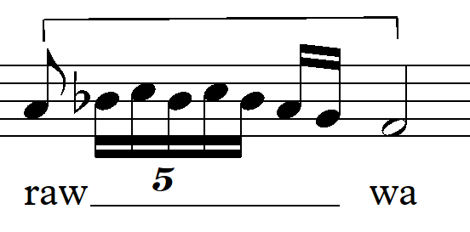
- Ornamentation of Mad Lazim Harfi Mutsaqqal in ‘annaa recitation with maqam Bayyati Husseini, uses jawab tone (high). Because there are two mad side by side, and therefore in ‘an syllable, there is ornamentation of adding 6 tones moving downward, not in naa syllable obtaining ornamentation. The notation form is as follows.
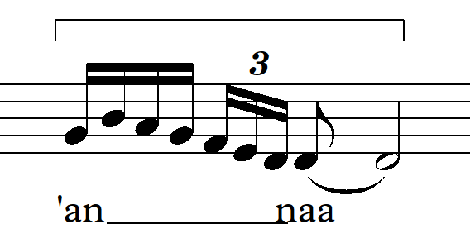
- Ornamentation of tanwin dhummah (un) meets ikhfa in letter fa’ (ف ) as seen in yunfiquun recitation in Surah Al Baqoroh verse 3, nun sukoon is recited vaguely or disappears sounded buzzing as yungfiquun named ikhfa Haqiqi. The recitation in maqam Bayyati Husseini applies jawab tone (high). The notes are as follows.
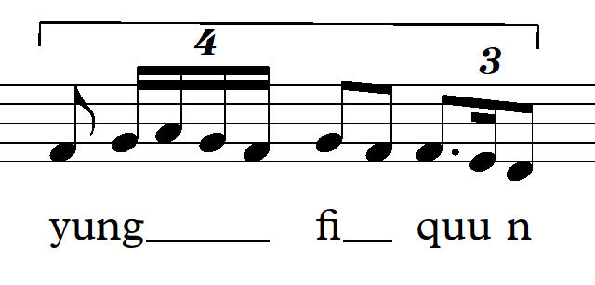
- Ornamentation occurs in tanwin fathatain (an) meets ikhfa in letter kaf ( ك ) like in the following example of huubankabiiroo recitation in Surah An Nisa verse 2, nun fathatain (an) is recited vaguely or disappears sounded buzzing as huubangkabiiroo. The recitation occurs in maqam Hijaz Kar. The notes are as follows. 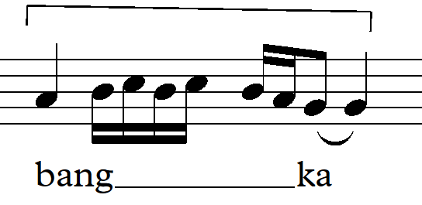
- Besides the above mention ornamentation, there are still many other versions which have not been mentioned in sound extension, as well as waves or vibration. It can be viewed in Muhammadun recitation in Surah Ali Imron verse 144, in ham syllable, there is ornamentation of vibration in maqam Bayyati recitation, using Qoror tone. Here is the notation.
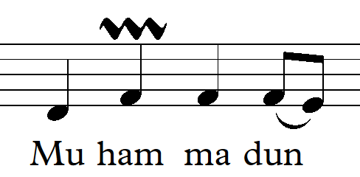

- CONCLUSION
Based on the discussion above, a conclusion can be drawn that the art of Al-Qur’an recitation or chanting in Indonesia refers to the version obtained from Egypt known as the song of Bayyati, Shaba, Hijaz, Nahawand, Sikah, Rast, Jiharkah. Considering that the language of Al-Qur’an is Arabic, and therefore in chanting Al-Qur’an verses, we must apply Arabic song (maqam) or known in Arabic ethnomusicology with maqamat Al-Arabiyyah. Ornamentation of the art of Al-Qur’an recitation in MTQ, in the National level, particularly the type of mujawwad often occurs in the sound extension or mad and in letters of ikhfa, although not all letters are given ornamentation in mad and ikhfa.
The forms of ornamentasi occurring in the art of Al-Qur’an recitation are more dominated by the ornamentation form of melisma, which is one syllable for several tones. Although other forms of ornamentation also occur like luk, which is one syllable for two or three tones (known as neumatic in Western music term). Besides, there is also ormanentation of gregel taht is the addition of one tone moving upward or downward quickly (known as appoggiatura in Western music. Next, there is also vibra ornamentation that is a smooth wave or vibration (known as such kind of trill in Western music term).

REFERENCES

Al-Faruqi, Isma’il Raji. 1999. Seni Tauhid: Esensi dan Ekspresi Estetika Islam. Yogyakarta: Bentang.

Arafat, M. Yasir. 2013. “Tarekat Tilawatiyah: Melantukan Al-Qur’an, Aspek Memakrifati Diri, Melakonkan Islam” Tesis Program Magister Antropologi Budaya, Fakultas Ilmu Budaya, Universitas Gadjah Mada.

Isma”il Al-Faruqi dan Lois Lamya Al-Faruqi. 1996. Atlas Budaya Islam.Kuala Lumpur, Malaysia.

Marquat, Linda. 2005. The Right Way To Sing. New York: Allworth Press.

Moleong, Lexy J.1999. Metodologi Penelitian Kualitatif. Bandung: PT. Rosda Karya.

Munawwir, Ahmad Warson.1997. Kamus Al-Munawwir. Surabaya: Pustaka Progressif.

Nasr, Seyyed Hossein. 1997.“Islam and Music: The Legal and Spiritual Dimensions”, Lawrence E. Sullivan (eds). Enchanting Powers: Music in the World’s Religions. Cambridge, Mass.: Harvard University Press for Harvard University Center for the Study of World Religions.

Nurudin Triyasyid. 2015. Pedoman Tajwid Mudan dan Aplikatif. Kartasura Solo: Taujih.

Omar, Abdul Rahman ben Hammad al-. 1996. The Religion of Truth. Saudi Arabia: Ministry of Islamic Affairs, Endowments, Da’wah and Guidance.

Rasmussen, Anne K. 2010. Women, The Recited Quran, and Islamic Music in Indonesia. USA: University of California Press.

Rizali, Nanang. 2012. “Kedudukan Seni Dalam Islam”, dalam Jurnal TSAQAFA, Jurnal Kajian Seni Budaya Islam Vol. I. Yogyakarta: Pustaka Pelajar.

Soedarsono, R.M. 1999. Metodologi Penelitian Seni Pertunjukan dan Seni Rupa. Bandung: MSPI.

Taylor, Eric. 2004. The ABC Guide to Music Theory (Part II). London: The Associated Board of the Royal Schools of Music.

